Aim
To create a cloud-based Flight Reservation System using Zoho Creator to demonstrate Software as a Service (SaaS), allowing users to submit and view flight reservation details online.
Procedure
- Open Zoho Creator and sign in using a Zoho account.
- Create an application named Flight Reservation System.
- Create a form named Flight Ticket.
- Add passenger details such as name, email address, and mobile number.
- Add Trip Type options: One Way and Round Trip.
- Add Flight Type options: Domestic and International.
- Add From, To, Departure Date, and Return Date fields.
- Add Travelers, Travel Class, and Fare Type fields with suitable options.
- Save the form and click Access This Application.
- Enter sample reservation details and click Submit.
- Open the associated report to view the saved reservation.
- Demonstrate accessing the application through a web browser as a cloud-
hosted service.

OUTPUT IMAGE

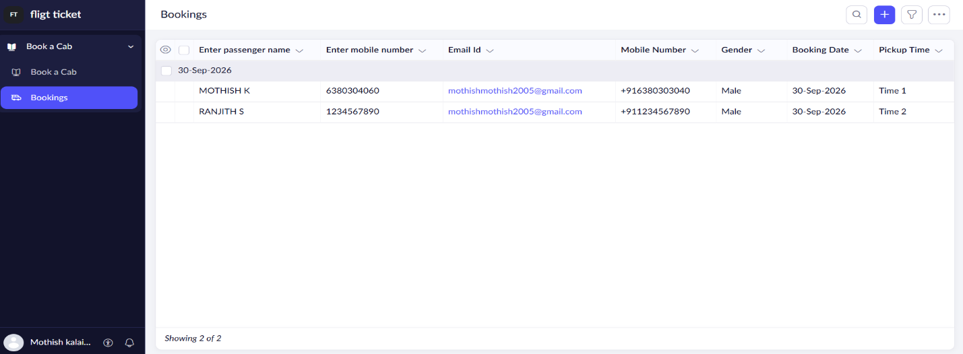
Result
A simple Flight Reservation System was created using Zoho Creator, demonstrating SaaS through online reservation entry and cloud-based storage of booking details.

